**Global Malnutrition Trends: A Power BI Analysis (1983-2019)**

**Introduction:**

ABC Company is undertaking an in-depth analysis of global malnutrition trends from 1983 to 2019 to better understand the prevalence and distribution of various forms of malnutrition among children under five years of age. Utilizing a comprehensive dataset from UNICEF/WHO/World Bank, the project aims to analyze severe wasting, wasting, stunting, underweight, and overweight conditions across different countries. By classifying countries according to their income levels (low, lower-middle, upper-middle, and high income) and other categories such as Least Developed Countries (LDC), Low Income Food Deficient (LIFD), Land Locked Developing Countries (LLDC), and Small Island Developing States (SIDS), the project seeks to uncover correlations between economic status and malnutrition rates. Through the use of advanced data visualization techniques in Power BI, including stacked bar charts and line charts, ABC Company aims to generate actionable insights that can guide policy-making and resource allocation to combat child malnutrition effectively.

Malnutrition remains a critical global health issue, with children in lower-income countries disproportionately affected. ABC Company aims to address the challenge of identifying key patterns and trends in child malnutrition data over several decades. The primary problem is to determine how various forms of malnutrition correlate with economic and geographical classifications of countries, and to identify which countries and regions are most affected. By leveraging historical data, the project will highlight areas needing urgent attention and support, helping stakeholders to prioritize interventions and strategies for reducing malnutrition and its associated health risks among children under five. This analysis is crucial for developing targeted, data-driven solutions to improve child health outcomes worldwide.

**Scenario 1:** Count of U5 Population (140)

This metric represents the number of observations related to the under-five population in the dataset. It indicates the sample size or the count of data points collected.

**Scenario 2:** Sum of Survey Sample (11M)

The total sum of survey samples collected is 11 million. This large sample size adds robustness to the analysis and findings, ensuring that the insights derived are based on a substantial amount of data.

**Scenario 3:** Sum of Underweight (2.08K)

The total number of underweight cases is 2,080. This highlights the prevalence of underweight conditions among children under five, which is a critical aspect of malnutrition to address.

**Scenario 4:** Sum of LDC,LIFD,LLDC or SID2 and Average of Stunting by Income Analysis

The visualization is about the average spending by income. The x-axis shows income classification, likely divided into segments, and the y-axis shows the average spending. There is a trend line that shows that as income classification goes up, average spending also goes up.

**Scenario 5:** Sum of Overweight by Country

The visualization is about the total number of overweight people in various countries, according to a dataset titled "Sum of Overweight".

**Scenario 6:** Sum of Overweight and Underweight under Income Classification.

The width of each ribbon segment (overweight or underweight) for a specific income level indicates the relative size of that population group within that income bracket. By following the ribbon's path, you can see if overweight or underweight populations become more or less dominant as income levels change.

**Scenario 7:** Sum of Income Classification

It represents the total income within each income bracket, but without knowing the number of people in each bracket, it's difficult to interpret. A high total could be due to a few very high earners or many people with moderate incomes. Labels for each income bracket (e.g., low, middle, high).

***Technical Architecture:***

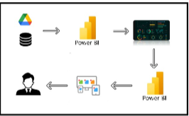

***Project Flow:`***

To accomplish this, we have to complete all the activities listed below,

* Data Collection
  + Collect the dataset,
  + Connect Data with Power BI
* Data Preparation
* Prepare the Data for Visualization
* Data Visualizations
  + Visualizations
* Dashboard
  + Responsive and Design of Dashboard
* Report
* Report Creation
* Performance Testing
  + Utilization of Data Filters
  + No. of Calculation fields
  + No. of Visualizations/Graphs
* Project Demonstration & Documentation
  + Record explanation Video for project end to end solution
  + Project Documentation-Step by step project development procedure

***Data Flow:***

***Milestone 1: Data Collection & Extraction from Database***

Data collection is the process of gathering and measuring information on variables of interest, in an established systematic fashion that enables one to answer stated research questions, test hypotheses, evaluate outcomes and generate insights from the data.

***Activity 1.1: understanding the data:***

Data contains all the meta information regarding the columns described in the CSV files.

**Dataset link:** [**https://www.kaggle.com/datasets/ruchi798/malnutrition-across-the-globe?select=malnutrition-estimates.csv**](https://www.kaggle.com/datasets/ruchi798/malnutrition-across-the-globe?select=malnutrition-estimates.csv)

***Column Description of the Dataset:***

* ISO code: Standardized two-letter country codes.
* Country: Name of the country.
* Survey Year: The year in which the survey data was collected.
* Year: The specific year of the data point.
* Income Classification: Income classification of countries (0: Low Income, 1: Lower Middle Income, 2: Upper Middle Income, 3: High Income).
* LDC: Indicator for Least Developed Countries (LDCs).
* LIFD: Indicator for Low Income Food Deficient (LIFD) countries.
* LLDC or SID2: Classification for Land Locked Developing Countries (1), Small Island Developing States (2), and Others (0).
* Survey Sample (N): The size of the survey sample.
* Severe Wasting: Average percentage of children with severe wasting.
* Wasting: Average percentage of children with wasting.
* Overweight: Average percentage of overweight children.
* Stunting: Average percentage of children with stunting.
* Underweight: Average percentage of underweight children.
* U5 Population ('000s): Population of children under five years old (in thousands).

***Milestone 2:* Data Preparation**

Preparing the data for visualization involves cleaning the data to remove irrelevant or missing data, transforming the data into a format that can be easily visualized, exploring the data to identify patterns and trends, filtering the data to focus on specific subsets of data, preparing the data for visualization software, and ensuring the data is accurate and complete. This process helps to make the data easily understandable and ready for creating visualizations to gain insights into the performance and efficiency. Since the data is already cleaned, we can move to visualization.

**3.1: Data Loading :** <https://drive.google.com/file/d/1iLQTWdG0chi6S9gUAvA0-7D6p8w1AYgO/view?usp=drive_link>

**3.2 Data Cleaning:**

<https://drive.google.com/file/d/10tD0YoSkfWKD3ZiGwkzF3qF1DevuliJ6/view?usp=sharing>

**1. Import Data into Power BI:**

* **File**: Imported Global Malnutrition from an CSV or database file into Power BI.
  + Go to **Home** > **Get Data** > Choose file format (e.g. CSV).
  + Load the data into Power BI.

**2. Clean the Data (Remove Nulls, Duplicate Data):**

* Go to **Transform Data** (Power Query Editor) to clean the data.
* **Remove Nulls**: Select columns and filter out null values.

In Power Query, select the column > Click on the **Filter** icon > Uncheck **null** to remove them.

* **Remove Duplicates**: If there are duplicate rows, remove them by:
  + Go to **Transform** > **Remove Duplicates**.
* **Rename Columns**: Ensure column names are consistent and clear.
* **Change Data Types**:
  + Ensure that columns like Year are formatted as **Whole Numbers** and formatted as a **Decimal**.

Done this in Power Query or directly in Power BI by selecting the column in the Data View and changed the data type.

**3. Save Data Preparation Steps:**

Once cleaned, transformed, click Close & Apply in the Power Query Editor to load changes into Power BI.

***Milestone-3: Data Visualization:***

Data visualization is the process of creating graphical representations of data to help people understand and explore the information. The goal of data visualization is to make complex data sets more accessible, intuitive, and easier to interpret. By using visual elements such as charts, graphs, and maps, data visualizations can help people quickly identify patterns, trends, and outliers in the data.

**Activity-1.1: Line Chart**

* **Purpose**: Track the trends for indicators like severe wasting, wasting, stunting, and underweight across time.
* **X-Axis**: Year
* **Y-Axis**: Separate lines for Severe Wasting, Wasting, Stunting, and Underweight.

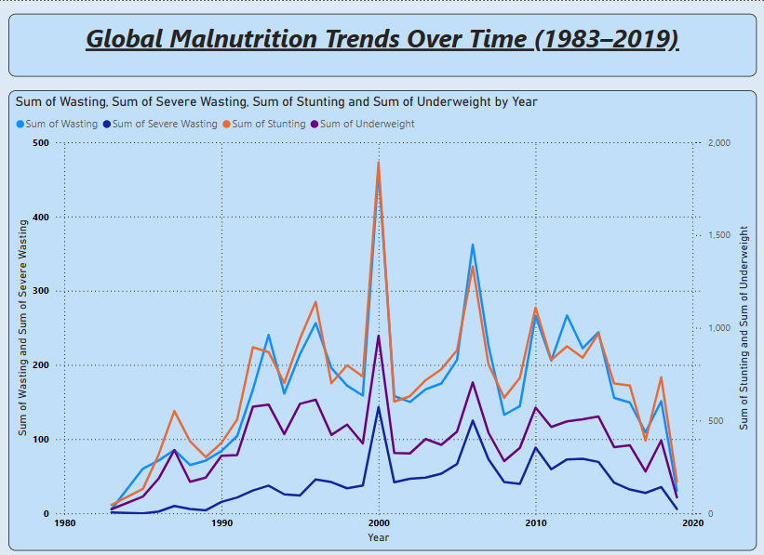

**Activity-1.2: Stacked Bar Chart**

* **Purpose**: Compare the average values of severe wasting, stunting, and underweight across countries.
* **X-Axis**: Country
* **Y-Axis**: AverageSevereWasting, AverageWasting, AverageStunting, AverageUnderweight.

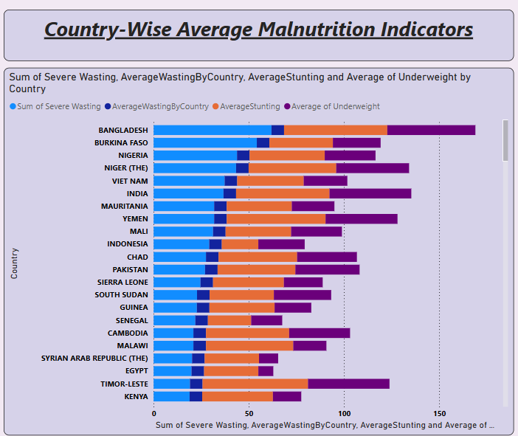

**Activity-1.3:** **Column Chart**

* **Purpose**: Identify the countries with the highest levels of severe wasting.
* **X-Axis**: Country
* **Y-Axis**: Severe Wasting

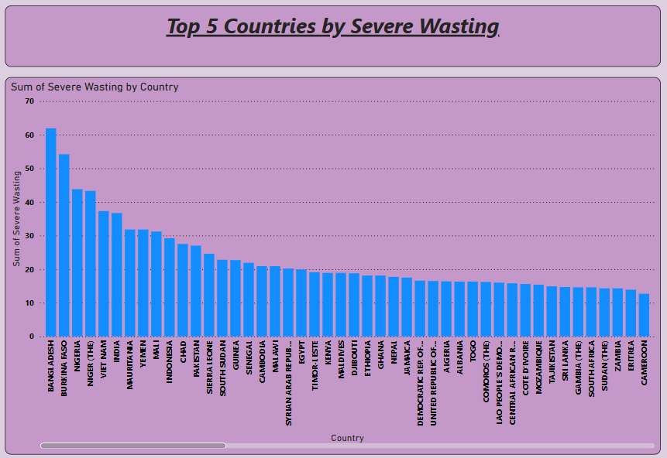

**Activity-1.4: Map**

* **Purpose:** Geographically display malnutrition indicators like severe wasting, stunting, etc.
* **Location:** Country (linked to the map using ISO code for better accuracy).
* **Color Saturation:** Severe Wasting, Wasting, Stunting, or other malnutrition indicators.

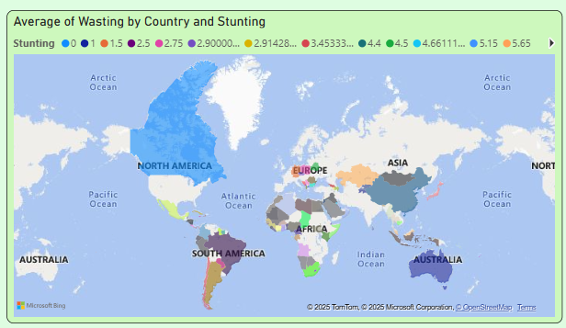

**Activity-1.5: Pie Chart**

* **Purpose**: Show the percentage of malnutrition based on income classification (Low, Middle, High).
* **Legend**: Income Classification
* **Values**: Average Severe Wasting, Wasting, Stunting, and Underweight.

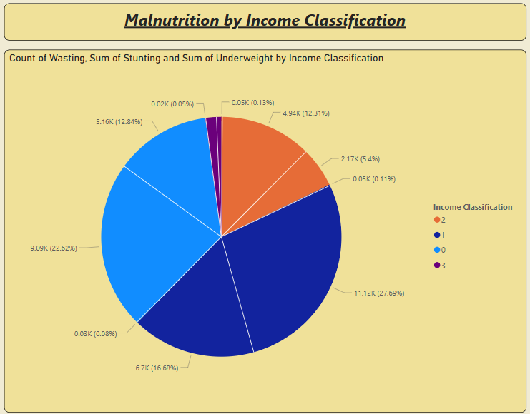

**Activity-1.6: Area Chart**

* **Purpose**: Visualize the cumulative malnutrition data across the years, showing the growth or reduction in severe wasting or underweight percentages.
* **X-Axis**: Year
* **Y-Axis**: CumulativeSevereWasting and CumulativeUnderweight.

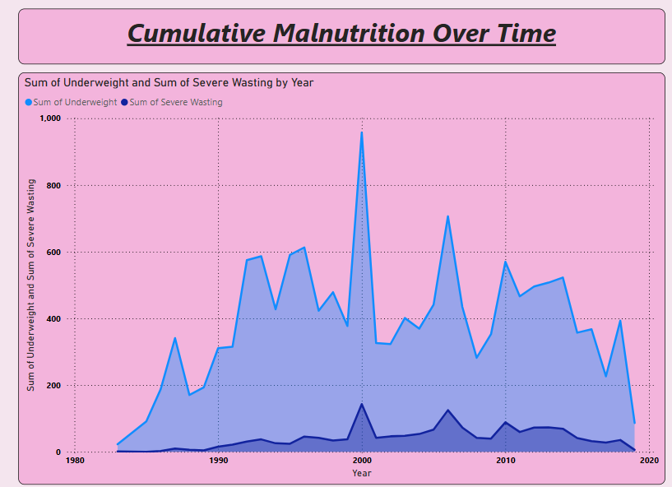

**Activity-1.7: Scatter Chart**

* **Purpose**: Compare how countries are performing in terms of underweight vs overweight children under 5.
* **X-Axis**: Underweight
* **Y-Axis**: Overweight
* **Size**: U5 Population ('000s)
* **Legend**: Country

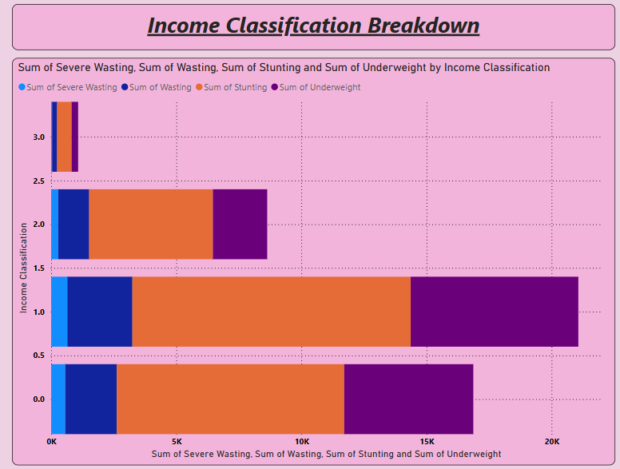

**Activity-1.8: Donut**

* **Purpose**: Show the percentage of malnutrition based on income classification (Low, Middle, High).
* **Legend**: year
* **Values**: severe wasting

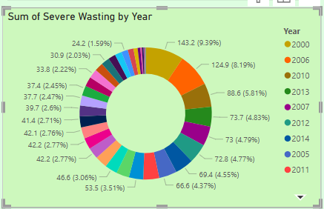

**Activity-1.9: Cards**

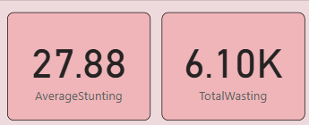

***Milestone-4: DashBoard***

A dashboard is a graphical user interface (GUI) that displays information and data in an organized, easy-to-read format. Dashboards are often used to provide real-time monitoring and analysis of data and are typically designed for a specific purpose or use case. Dashboards can be used in a variety of settings, such as business, finance, manufacturing, healthcare, and many other industries. They can be used to track key performance indicators (KPIs), monitor performance metrics, and display data in the form of charts, graphs, and tables.

**Activity 1- Responsive and Design of Dashboard**

Created a responsive and well-designed dashboard in Power BI is key to effectively communicating of data insights*.*

**Explanation video link:**<https://drive.google.com/file/d/12Eap_FYCKmoFhVjzJgd3pKs-sPr_rkRg/view?usp=sharing>

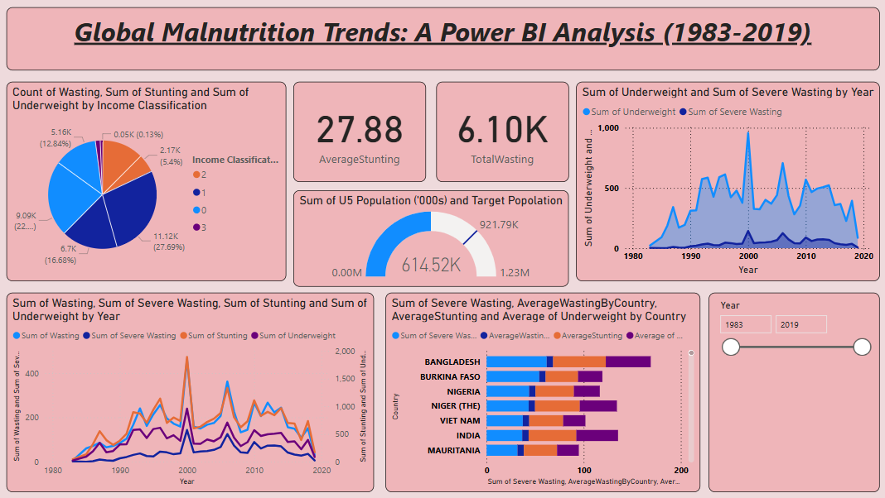

***Milestone 5: Report***

A report is a comprehensive document that provides a detailed and structured account of data analysis, findings, and insights. It is typically used for in-depth analysis, documentation, and communication of results. Reports are suitable for a diverse audience, including decision-makers, analysts, and stakeholders who need a comprehensive understanding of the data.

**Activity 1- Design of Report**

Designing a report in Power BI involves connecting to data sources, creating visualizations like charts and graphs, customizing their appearance and interactivity, organizing them logically on the canvas, formatting elements for consistency and clarity, and optionally creating dashboards for a summarized view. Throughout the process, it's essential to consider the audience's needs and ensure the report effectively communicates insights from the data. Finally, iterate based on feedback to continually improve the report's design and usefulness.

**Explanation video link:** <https://drive.google.com/file/d/1IhDJocs7l8KiszGxItoAo4JkDxjIqyjU/view?usp=sharing>

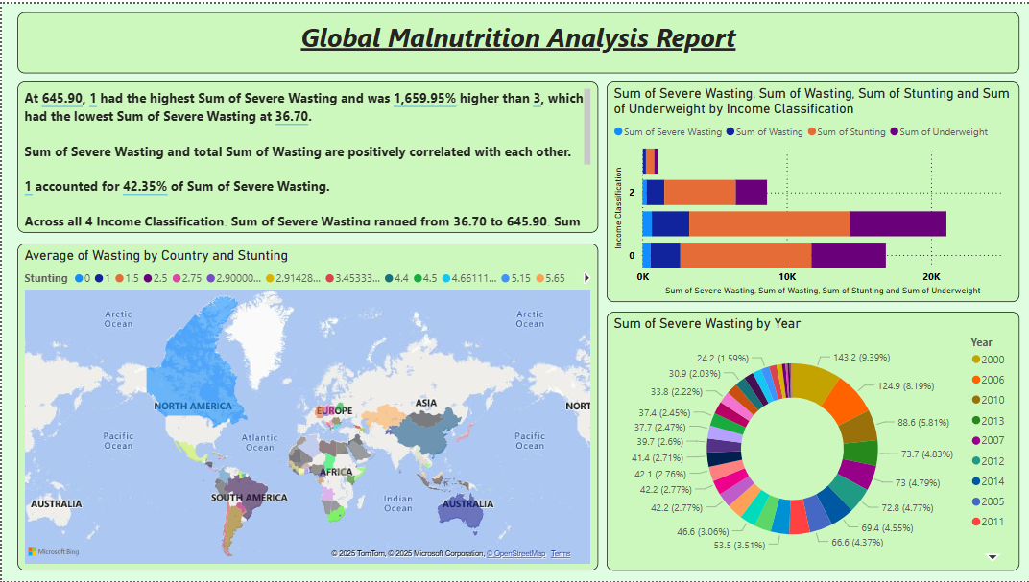

***Milestone-6:* Performance Testing**

**Activity 1- Amount of Data Loaded**

"Amount of Data Loaded" refers to the quantity or volume of data that has been imported, retrieved, or loaded into a system, software application, database, or any other data storage or processing environment. It's a measure of how much data has been successfully processed and made available for analysis, manipulation, or use within the system.

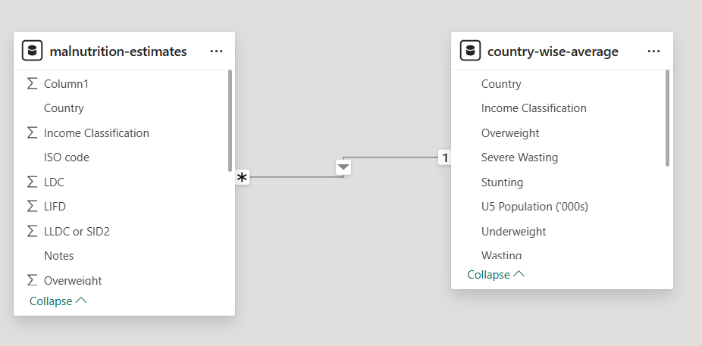

**Activity -2: Utilization of Filters**

"Utilization of Filters" refers to the application or use of filters within a system, software application, or data processing pipeline to selectively extract, manipulate, or analyze data based on specified criteria or conditions.

**Activity -2.1: AverageStunting**



**Activity -2.2: AverageWastingByCountry**



**Activity -2.3: Target Popolation**



**Activity -2.4: TotalSevereWasting**



**Activity -2.5: TotalWasting**



**Activity -2.6: UnderweightPercentage**



**Activity -2.7:** **WastingPercentage**

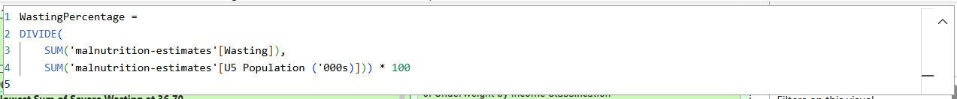

***Activity-2:* No of Visualizations/ Graphs:**

1.Line Chart

2.Stacked Bar Chart

3.Column Chart

4.Map

5.Pie Chart

6. Area Chart

7.Scatter Chart

8.Donut

9.Cards

***Milestone 7: Project Demonstration & Documentation:***

**Activity 1: - Record explanation Video for the project's end-to-end solution**

**Activity 2: - Project Documentation-Step by step project development procedure**